Supplementary Materials
Associative learning is sufficient to explain infants’ putative action efficiency
Deon T. Benton
Correspondence to: Deon T. Benton (deon.benton@vanderbilt.edu)

This file includes materials for:
- Simulation 1a: Selective longer looking to inefficient actions.
Simulation 1b: How prior experience with unconstrained action impacts processing.
- Simulation 2: Independence from animacy.
- Simulation 3: Bidirectional inferences about actions, goals, and constraints.
- Simulation 4: Graded representations of efficiency.
- Simulation 5: Action efficiency understanding in pre-reaching infants.

The aim of this section is to demonstrate that ALIAS’s performance in the main manuscript was robust to different salience learning rate and weight decay parameter values and to different developmental learning rates. The alternative salience learning rates were 0.0003875 and 0.0004; the weight decay values were 0.0975 and 0.09875. These ranges were used across the five simulations. However, because the specific developmental learning rate value range depended on the simulation, those values are reported in the simulation itself. Note that all results reported below held across habituation lengths, developmental and salience learning rates, and salience weight decays.

I. Simulation 1a: Selective longer looking to inefficient actions

Figure S1. Mean network error produced to the Efficient and Inefficient test events in the Experimental and Control conditions as a function of habituation length, developmental learning rate, salience learning rate, and salience weight decay.

The range of developmental learning rates used here was 0.0975 and 0.09875. Figure S1 shows that networks in the Experimental condition produced more error to the Inefficient than to the Efficient test event. In contrast, networks in the Control condition produced comparable error to both test events.

II. Simulation 1b: How prior experience with unconstrained action impacts processing
The range of parameter values used in this simulation was identical to that in Simulation 1a. Results are reported separately for the two pairs of salience learning rate and weight decay values to facilitate interpretation of the corresponding figures.
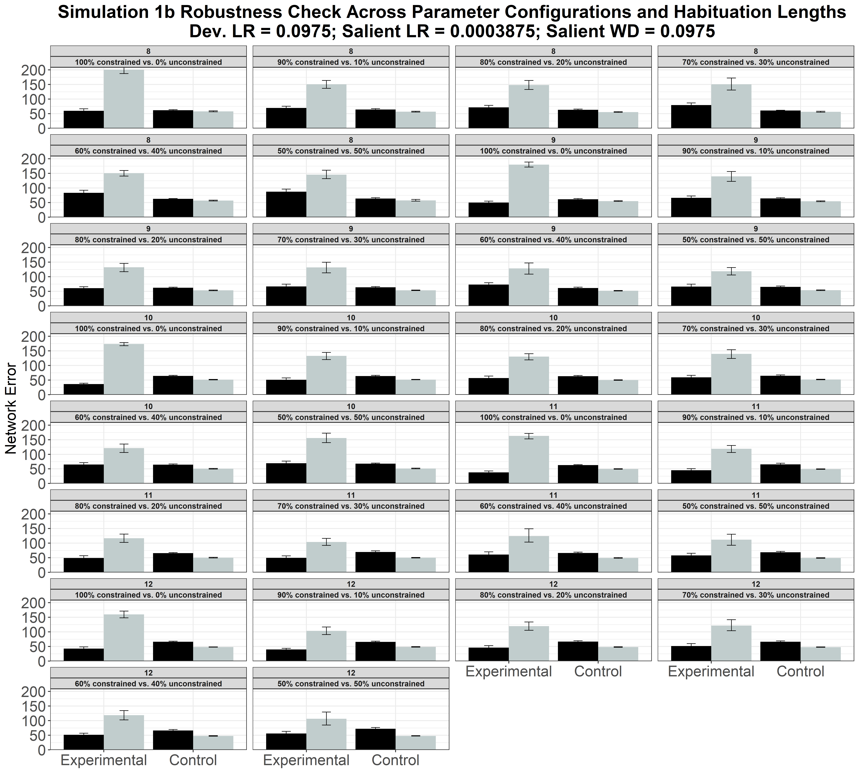
Figure S2. Mean network error produced to the Efficient and Inefficient test events in the Experimental and Control conditions as a function of habituation length and pretraining ratio of constrained to unconstrained motion.
Figure S2 shows the results for the model that used a salience learning rate of 0.0003875 and a salience weight decay of 0.0975. This figure shows that, as above, networks in the Experimental condition produced more error to the Inefficient than to the Efficient test event, whereas networks in the Control condition produced comparable error to both test events.

III. Simulation 2: Independence from animacy.

Figure S3. Mean network error produced to the Efficient and Inefficient test events in the Experimental and Control conditions as a function of habituation length, developmental and salience learning rates, and salience weight decay.
The range of developmental learning rates used here was 0.0875 and 0.08625. Figure S3 shows that networks in the Experimental condition produced greater error to the Inefficient than to the Efficient test event; networks in the Control condition produced comparable error to both test events.
IV. Simulation 3: Bidirectional inferences about actions, goals, and constraints.

Figure S4. Mean network error produced to the No-Obstacle and Obstacle test events as a function of habituation length, developmental and salience learning rates, and salience weight decay.

The range of developmental learning rates was identical to Simulation 1. Figure S4 shows the results for networks in the Inferring Goals condition. Networks produced more error to the No-Obstacle than to the Obstacle test event.

Figure S5. Mean network error produced to the Congruent and Incongruent test events as a function of habituation length, developmental and salience learning rates, and salience weight decay.

Figure S5 shows the results for networks in the Inferring Constraints condition. Networks produced more error to the Congruent than to the Incongruent test event.

V. Simulation 4: Graded representations of efficiency.

Figure S6. Mean network error produced to the High, inefficient and Low, efficient test events across experiments and as a function of habituation length, developmental and salience learning rates, and salience weight decay.
The range of developmental learning rates were identical to those in Simulation 2. Figure S6 shows that networks in Experiments 1 and 3 produced more error to the High, inefficient than to the Low, efficient test event. Networks in Experiment 2 produced more error to the Low, efficient than to the High, inefficient test event.

VI. Simulation 5: Action efficiency understanding in pre-reaching infants.


Figure S7. Performance of networks in the Effective condition. Networks’ mean error to the Efficient and Inefficient test events in the Experimental (top row) and Control conditions (bottom row) across different habituation lengths, developmental and salience learning rates, and salience weight decays.

The range of developmental learning rates used here was 0.01 and 0.00875. Figure S7 shows that networks in the Experimental condition produced more error to the Inefficient than to the Efficient test event, whereas networks the Control condition looked about equally long at both test events.

Figure S8. Performance of networks in the Ineffective condition. Shown is networks’ mean error to the Efficient and Inefficient test events across different habituation lengths, developmental and salience learning rates, and salience weight decays.

Figure S8 shows that networks in the Ineffective condition produced equivalent error to the Inefficient and Efficient test events.



Figure S9. Performance of networks in the No Training condition. Networks’ mean error to the Efficient and Inefficient test events in the Experimental (top row) and Control conditions (bottom row) across different habituation lengths, developmental and salience learning rates, and salience weight decays.

Figure S9 shows that, like networks in the Ineffective condition, those in the No Training condition networks produced about equivalent error to the Inefficient and Efficient test events.

Conclusion
Taken together, these qualitative analyses indicate that the results reported in the main paper were robust and did not depend on any particular parameter value.

